**Programming 2 (I)**

**Question: Based on the above example. modify Exercise 1 into Class Diagram.**

Answer:

1. Rabbit

Example breed of rabbit:

|  |
| --- |
| <<java class>>  Rabbit |
| Attributes / Properties:   * skinColor: String * size: String * weight : double * breed : String |
| Behaviour / Methods:   * eat () : void * sleep () : void * hop () : void * dig (): void |

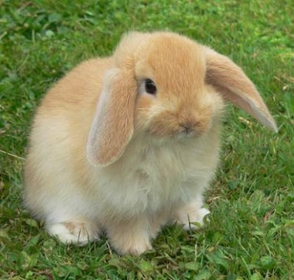

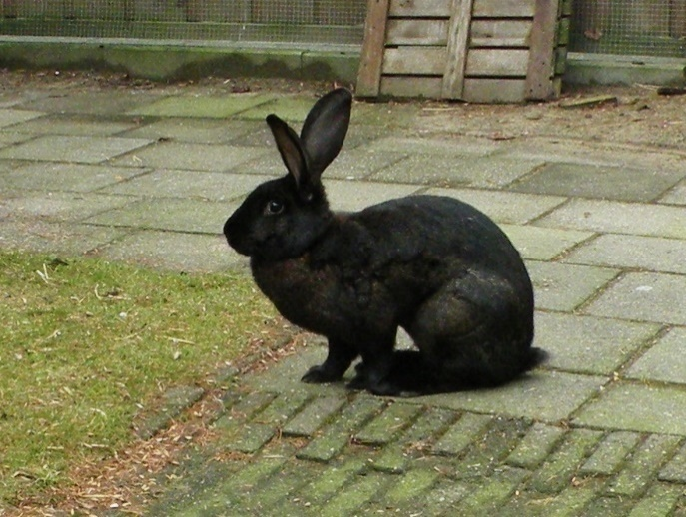

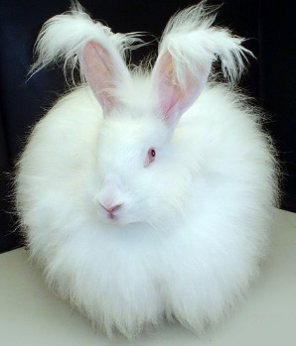

1. Laptop

Example brand of laptop:

|  |
| --- |
| <<java class>>  Laptop |
| Attributes / Properties:   * model: String * color : String * brand : String * operatingSystem : String |
| Behaviour / Methods:   * typing() : void * videoMeeting() : void * gaming () : void * webSearching(): void |

## 

## 

## 

## 

1. Cat

Example breed of cat:

|  |
| --- |
| <<java class>>  Cat |
| Attributes / Properties:   * breed : String * skinColor: String * weight : double |
| Behaviour / Methods:   * walk () : void * run () : void * climb(): void * sleep(): void * eat(): void |

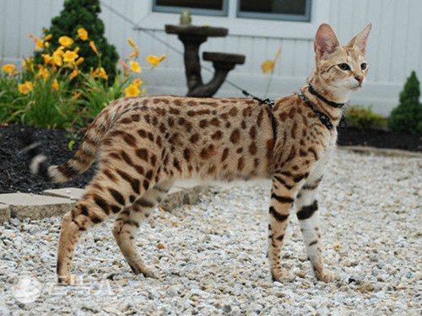

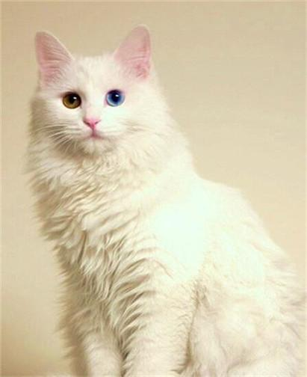

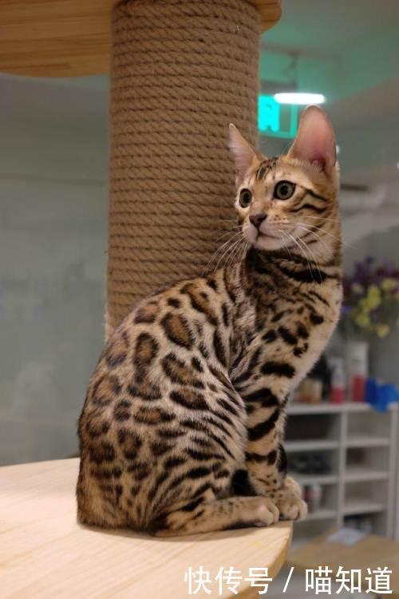

1. ­­­Mouse (Wireless)

Example brand of mouse:

|  |
| --- |
| <<java class>>  Mouse |
| Attributes / Properties:   * model: String * color : String * brand: String * wireless: boolean |
| Behaviour / Methods:   * clicking() : void * scrolling () : void * controllingArrowKey () : void |

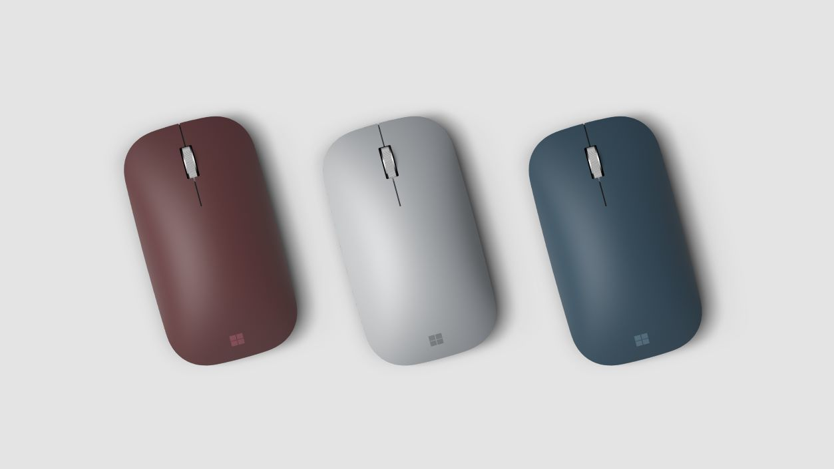

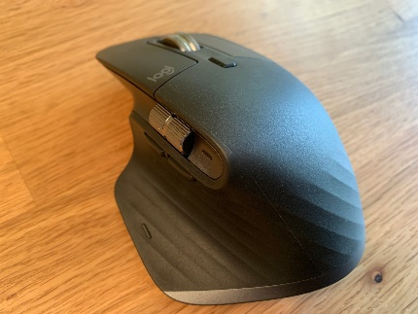

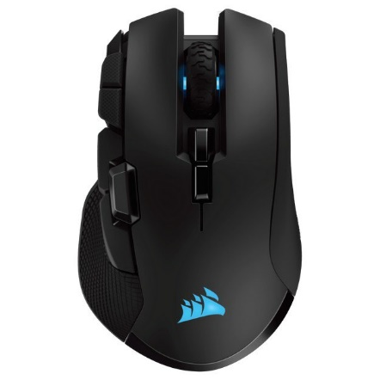

1. Smartwatch

Example brand of smartwatch:

|  |
| --- |
| <<java class>>  Smartwatch |
| Atrributes / Properties:   * model: String * color : String * brand : String |
| Behaviour / Methods:   * calling () : int * bluetooth() : void * messaging () : void * touchscreen() : void * detect() : void |

